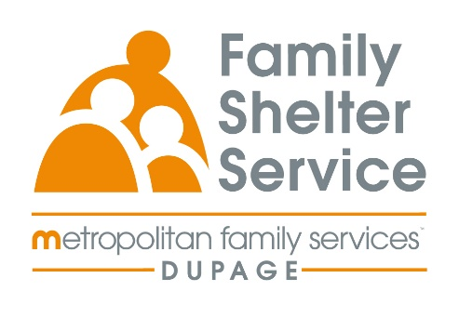
40hr Domestic Violence Training
September 22 - 25, 2026
Time: Tuesday – Friday
20/20: ICADV Modules & In-Person

Training Schedule:

Tuesday, Sept. 22nd 9:30-11:30am Welcome & Recap
12:30-3:30pm Effect of DV on Children

Wednesday, Sept. 23rd 9:00am – 12:00pm TDV & Post Separation Abuse
1:00-4:00pm Cultural Humility

Thursday, September 24th 9:00am-12:00pm Services for Survivors Part 1
1:00-4:00pm Services for Survivors Part 2

Friday, Sept. 25th 9:00am-12:00pm Safety & Assessment

Registration link: https://www.eventbrite.com/e/2020-dv-training-september-2026-tickets-1988941092348?aff=oddtdtcreator

Registration opens: May 20 @ 10am
Registration closes: September 4 @ 10am

