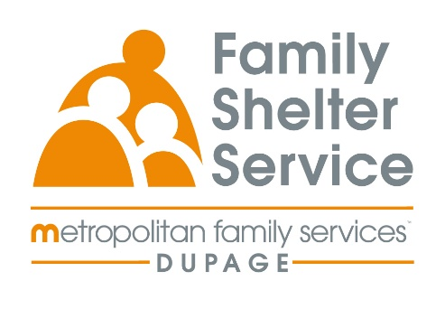
40hr Domestic Violence Training
October 13,14,15 &16, 2026
Time: Tuesday – Friday
20/20: ICADV Modules & In-Person

Training Schedule:

Tuesday, October13th 9:30-11:30am Welcome & Recap
12:30-3:30pm Effect of DV on Children

Wednesday, October 14th 9:00am – 12:00pm TDV & Post Separation Abuse
1:00-4:00pm Cultural Humility

Thursday, October 15th 9:00am-12:00pm Services for Survivors Part 1
1:00-4:00pm Services for Survivors Part 2

Friday, October 16th 9:00am-12:00pm Safety & Assessment

Registration Link: https://www.eventbrite.com/e/2020-dv-training-october-2026-tickets-1988945032132?aff=oddtdtcreator

Registration opens: May 20 @ 10am
Registration closes: September 28 @ 10am

