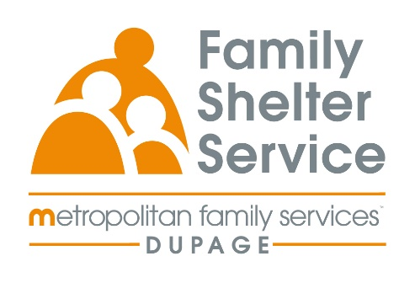
40hr Domestic Violence Training
January 20, 21, 22 & 23, 2026
Time: Tuesday – Friday
20/20: ICADV Modules & In-Person

Training Schedule:

Tuesday, January 20th 9:30-11:30am Welcome & Recap
12:30-3:30pm Effect of DV on Children

Wednesday, January 21 9:00am – 12:00pm TDV & Post Separation Abuse
1:00-4:00pm Cultural Humility

Thursday, January 23rd 9:00am-12:00pm Services for Survivors Part 1
1:00-4:00pm Services for Survivors Part 2

Friday, January 24th 9:00am-12:00pm Safety & Assessment

Registration Link: https://www.eventbrite.com/e/2020-dv-training-january-2026-tickets-1975123369166?aff=oddtdtcreator

Registration opens: December 3rd at 9am
Registration closes: January 2nd at 9am

