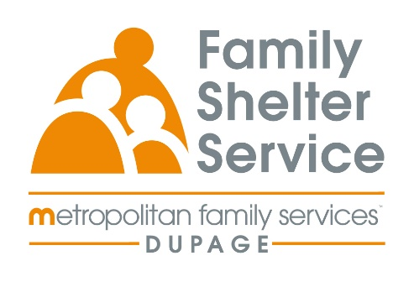
40hr Domestic Violence Training
April 14,15,16 & 17, 2026
Time: Tuesday – Friday
20/20: ICADV Modules & In-Person

Training Schedule:

Tuesday, April 14th 9:30-11:30am Welcome & Recap
12:30-3:30pm Effect of DV on Children

Wednesday, April 15th 9:00am – 12:00pm TDV & Post Separation Abuse
1:00-4:00pm Cultural Humility

Thursday, April 16th 9:00am-12:00pm Services for Survivors Part 1
1:00-4:00pm Services for Survivors Part 2

Friday, April 17th 9:00am-12:00pm Safety & Assessment

Registration Link: https://www.eventbrite.com/e/2020-dv-training-april-2026-tickets-1975132082227?aff=oddtdtcreator

Registration opens: December 3rd at 9am
Registration closes: March 26th at 10am

