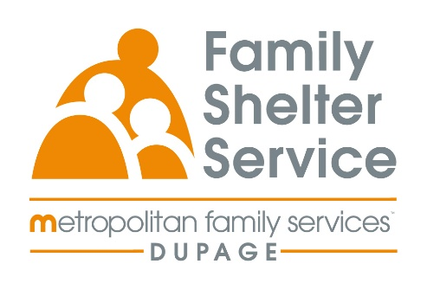
40hr Domestic Violence Training
September 8-11th, 15-17th
Time: Monday-Thursday 5:30-7:30 or 5:30-8:30pm
20/20: ICADV Modules & In-Person

Training Schedule:

Monday, September 8th 5:30-7:30pm Welcome & Recap

Tuesday, September 9th 5:30-8:30pm Effects of DV on Children

Wednesday, September 10th 5:30-8:30pm TDV & Post Separation Abuse

Thursday, September 11th 5:30-8:30pm Cultural Humility

Monday, September 15th 5:30-8:30pm Services for Survivors Part 1

Tuesday, September 16th 5:30-8:30pm Services for Survivors Part 2

Wednesday, September 17th 5:30-8:30pm Safety & Assessment

Registration Link: : : https://www.eventbrite.com/e/2020-dv-training-september-2025-tickets-1360795147919?aff=oddtdtcreator

Registration opens: May 14 at 9am
Registration closes: August 22nd at 9am

