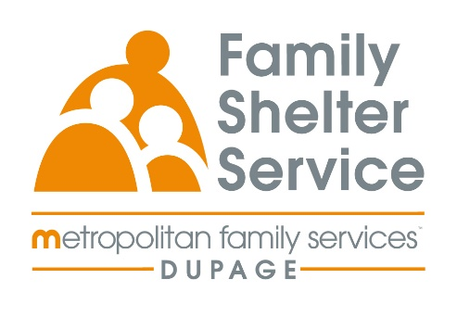
40hr Domestic Violence Training
October 20-23rd
Time: Monday – Thursday 9a-3pm or 9a-4pm
20/20: ICADV Modules & In-Person

Training Schedule:

Monday, October 20th 9:00-11:00am Welcome & Recap
12:00-3:00pm Effects of DV on Children

Tuesday, October 21st 9:00-12:00pm TDV & Post Separation Abuse
1:00-4:00pm Cultural Humility

Wednesday, October 22nd 9:00-12:00pm Services for Survivors Part 1
1:00-4:00pm Services for Survivors Part 2

Thursday, October 23rd 9:00-12:00pm Safety & Assessment

Registration Link: https://www.eventbrite.com/e/2020-dv-training-october-2025-tickets-1360808919109?aff=oddtdtcreator

Registration opens: May 14 at 9am
Registration closes: October 3rd at 9am

