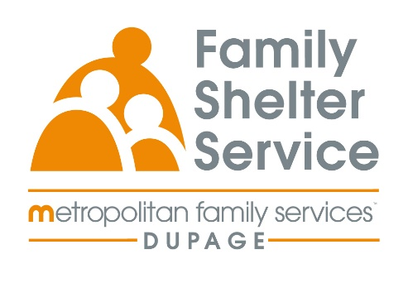
40hr Domestic Violence Training
November 3-6th
Time: Monday – Thursday 9a-3pm or 9a-4pm
20/20: ICADV Modules & In-Person

Training Schedule:

Monday, November 3rd 9:00-11:00am Welcome & Recap
12:00-3:00pm Effects of DV on Children

Tuesday, November 4th 9:00-12:00pm TDV & Post Separation Abuse
1:00-4:00pm Cultural Humility

Wednesday, November 5th 9:00-12:00pm Services for Survivors Part 1
1:00-4:00pm Services for Survivors Part 2

Thursday, November 6th 9:00-12:00pm Safety & Assessment

Registration Link: https://www.eventbrite.com/e/2020-dv-training-november-2025-tickets-1360809691419?aff=oddtdtcreator

Registration opens: May 14th at 9am
Registration closes: October 17th at 9am

